Landon Ashlin

Unix Programming

September 26, 2022

Assignment Three

*Question Two*

Absolute pathname of home directory: /home/centos/landon

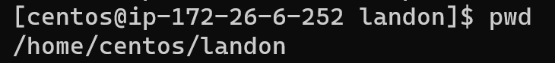

*Question Three*

*Question Four*

*Question Five*

landon

fun

Misc

summer.2007

Vacations

Chapter7Homework

Cal

Chapter8Homework